Kanan Ibadzade

Efe Gur Bahadir, Jarred Chen Measurements, and Error Analysis

# OBJECTIVE

The primary objective of this experiment is to improve measurement skills using various tools, including the vernier calipers, meter stick, metric ruler, triple-beam balance, digital balance, and micrometer. The general error propagation equation will assess the errors present in calculations employing observations and their associated uncertainties. It will also be used to understand the uncertainties related to each instrument.

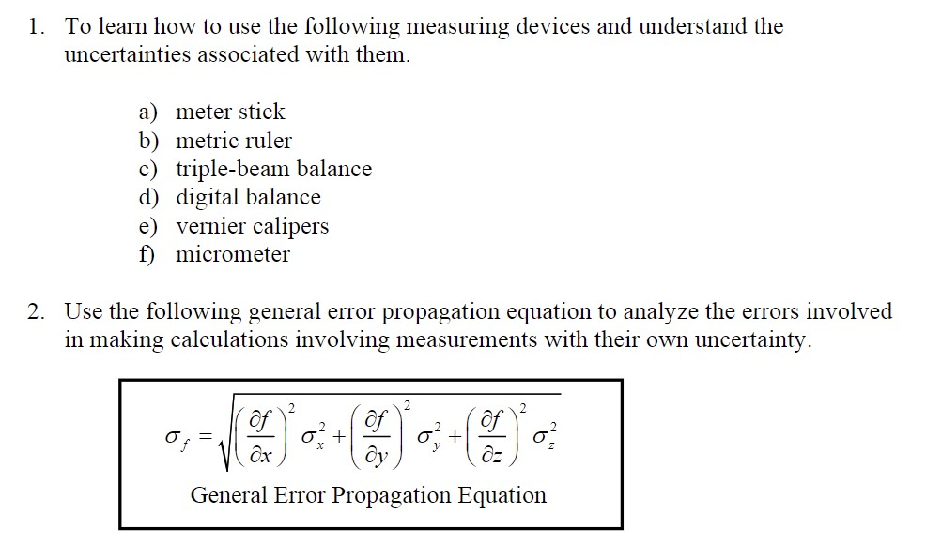

# THEORY

The process of calculating the impact of uncertainty in a computed result on uncertainty in measured quantities is known as error propagation. It aids comprehension of the mathematical processes that combine mistakes. The fractional uncertainties, for instance, increase when multiplying or dividing measured quantities. The proper estimation of uncertainty in experimental physics computations depends on this idea.

we have quantities X (length), Y (width), and Z (height) with respective uncertainties σx, σy, and σz. To calculate uncertainty in Z (σz), we can determine it using the formula:

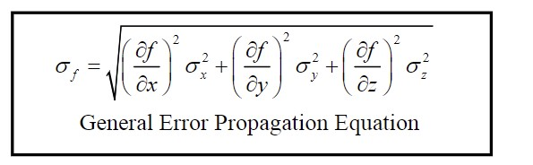

This formula helps us to find and demonstrates how the uncertainties in Length (X) and Width (Y) contribute to the uncertainty in the product representing Height (Z).

## APPARATUS

1)Meter Stick to measure the dimensions of the table-top.

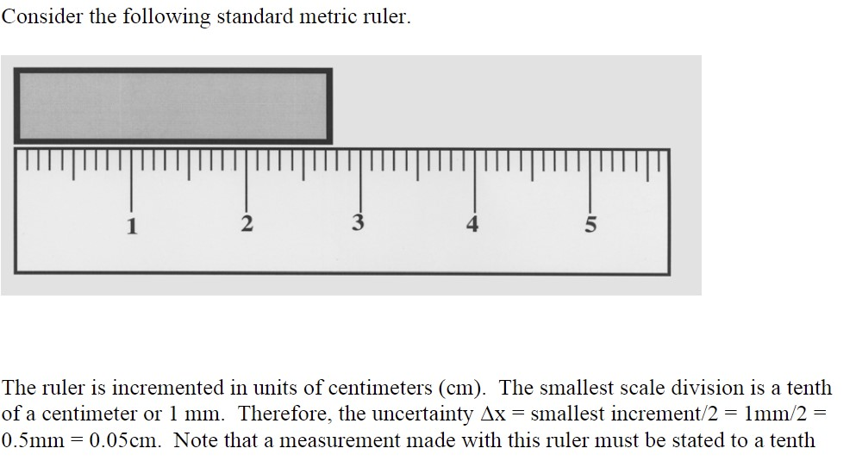



1. Metric Ruler, Vernier Calipers, and Micrometers to Measure the dimensions of the aluminum block with the serial number of XP7.

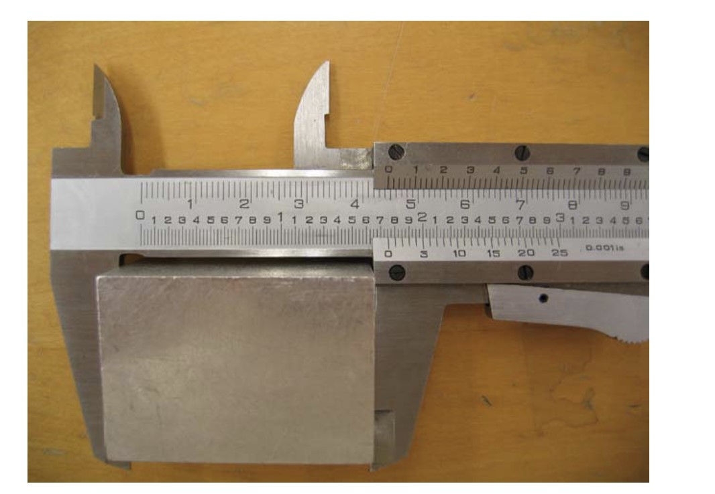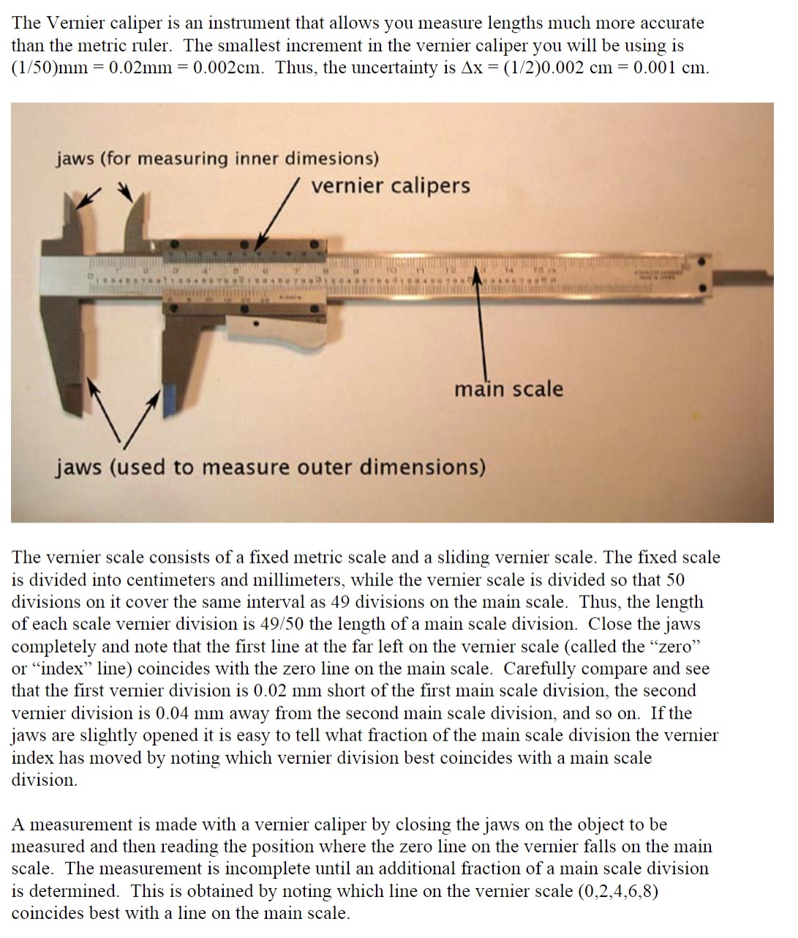

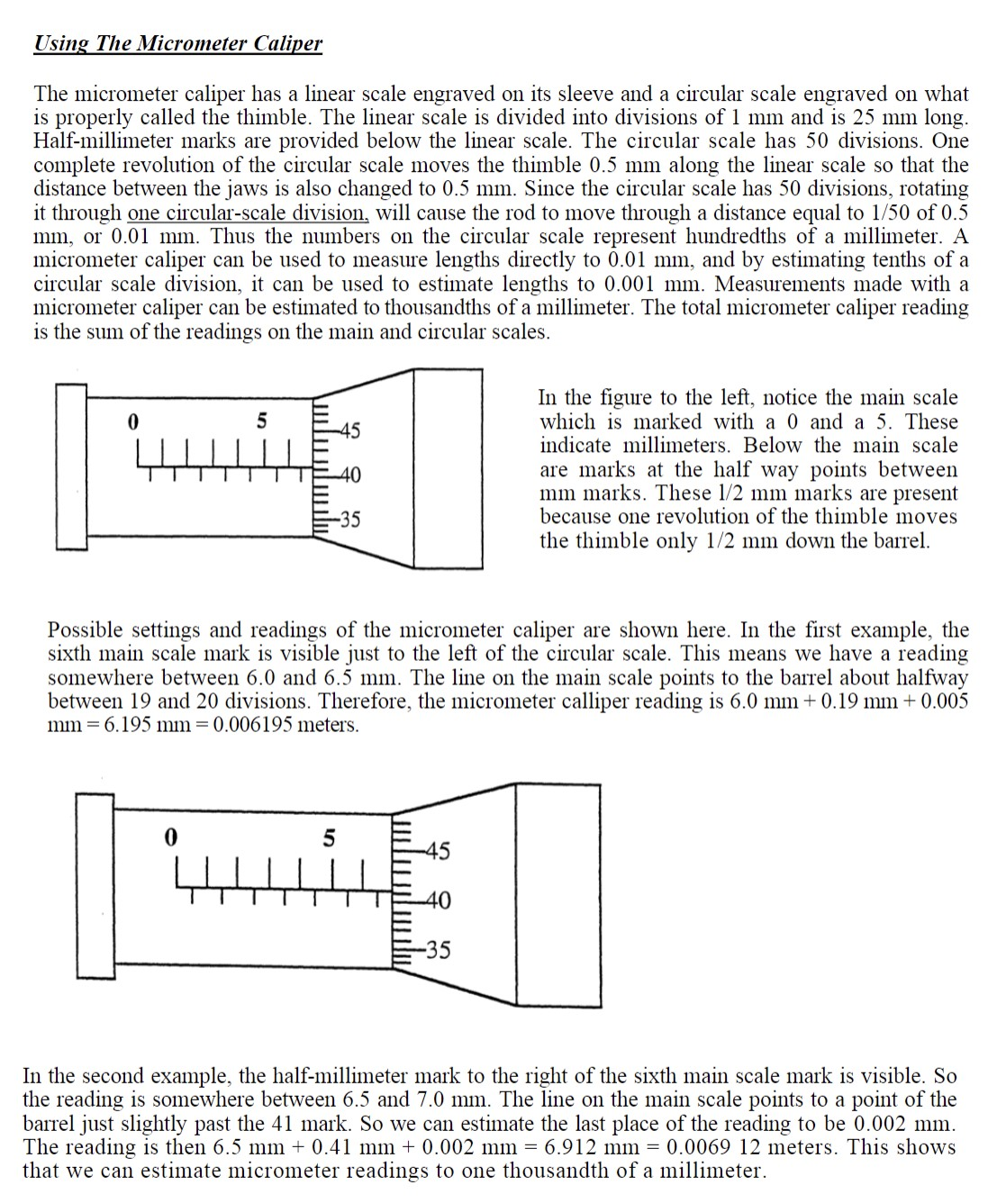

1. The Digital Balance and Triple-Beam Balance to Measure the mass of the aluminum block with the serial number of XP7.

## PROCEDURE

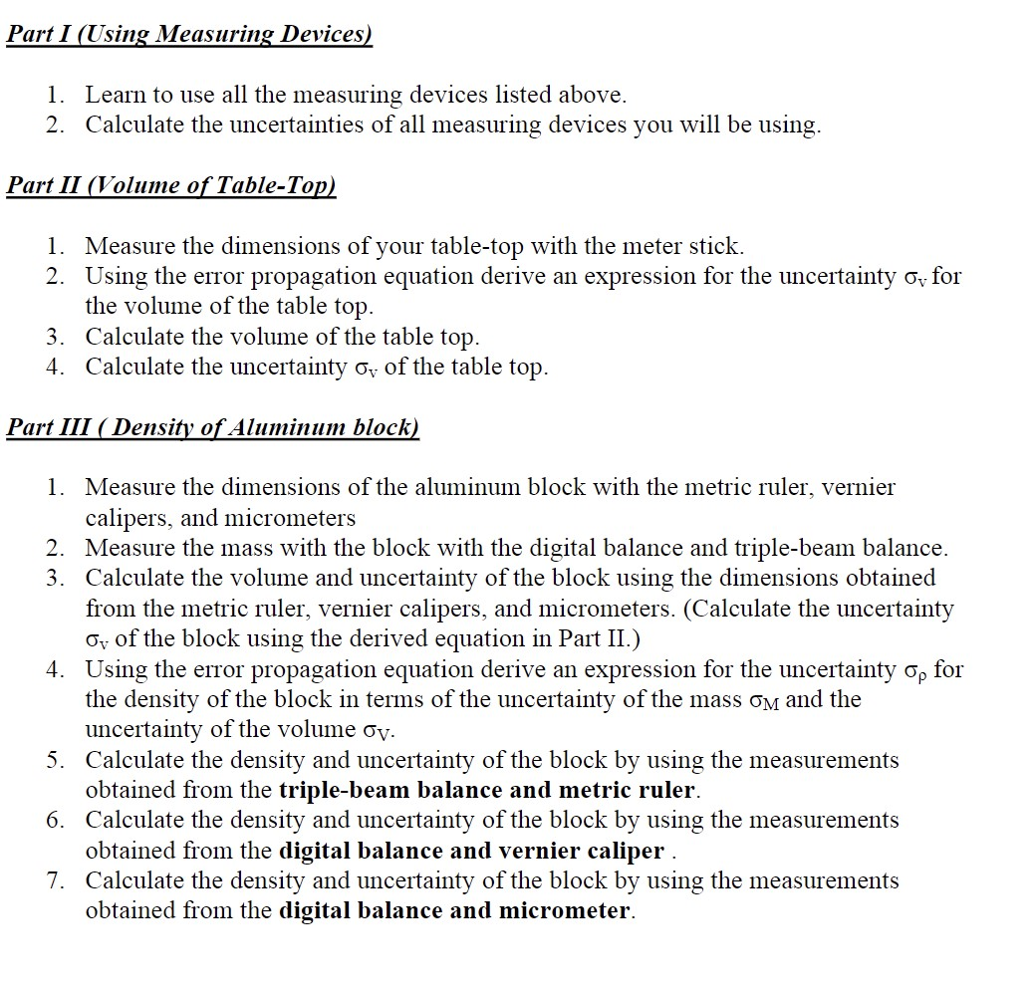

DATA

Device

Smallest

σx

MR

mm

1

mm

0.5

MS

mm

1

mm

0.5

TBB

g

0.1

g

0.05

DB

0.01

g

0.01

g

VC

cm

0.002

0.001

cm

MM

0.01

mm

0.005

mm

|  |  |  |  |  |  |  |  |  |  |  |  |  |  |  |  |  |  |  |
| --- | --- | --- | --- | --- | --- | --- | --- | --- | --- | --- | --- | --- | --- | --- | --- | --- | --- | --- |
| Table  Top | Y(length) | | | | | | X(width) | | | | | | | Z(depth) | | | | |
| Meter stick | 213.3±0.05cm | | | | | | 91.4±0.05cm | | | | | | | 3.4±0.05cm | | | | |
| aluminum block | | X(length) | | | | | | |  | Y(width) | | | | |  | Z(depth) | | | | | | |
| Metric ruler | | 10 | ±0.05cm | | |  | | |  | 2 | ±0.05cm | |  | |  | 1.5 | ±0.05cm | | |  | | |
|  | | |  | |  | | |
| Vernier caliper | | 9.994 | | ±0.001cm | | | |  |  | 1.86±0.001cm | | | | |  | 1.41 | | ±0.001cm | | |  | |
|  | | | |  | | |
| micrometers | | 99.325 | | | ±0.005mm | | | |  | 21.29 | | ±0.005mm | | |  | 16.9 | | ±0.005mm | | | |  |
|  | | | |  | | |  | | | |

Aluminum

block

Digital

balance

10.545

±0.01

g

Triple-

beam

balance

9.08

±0.05

g

## CALCULATIONS

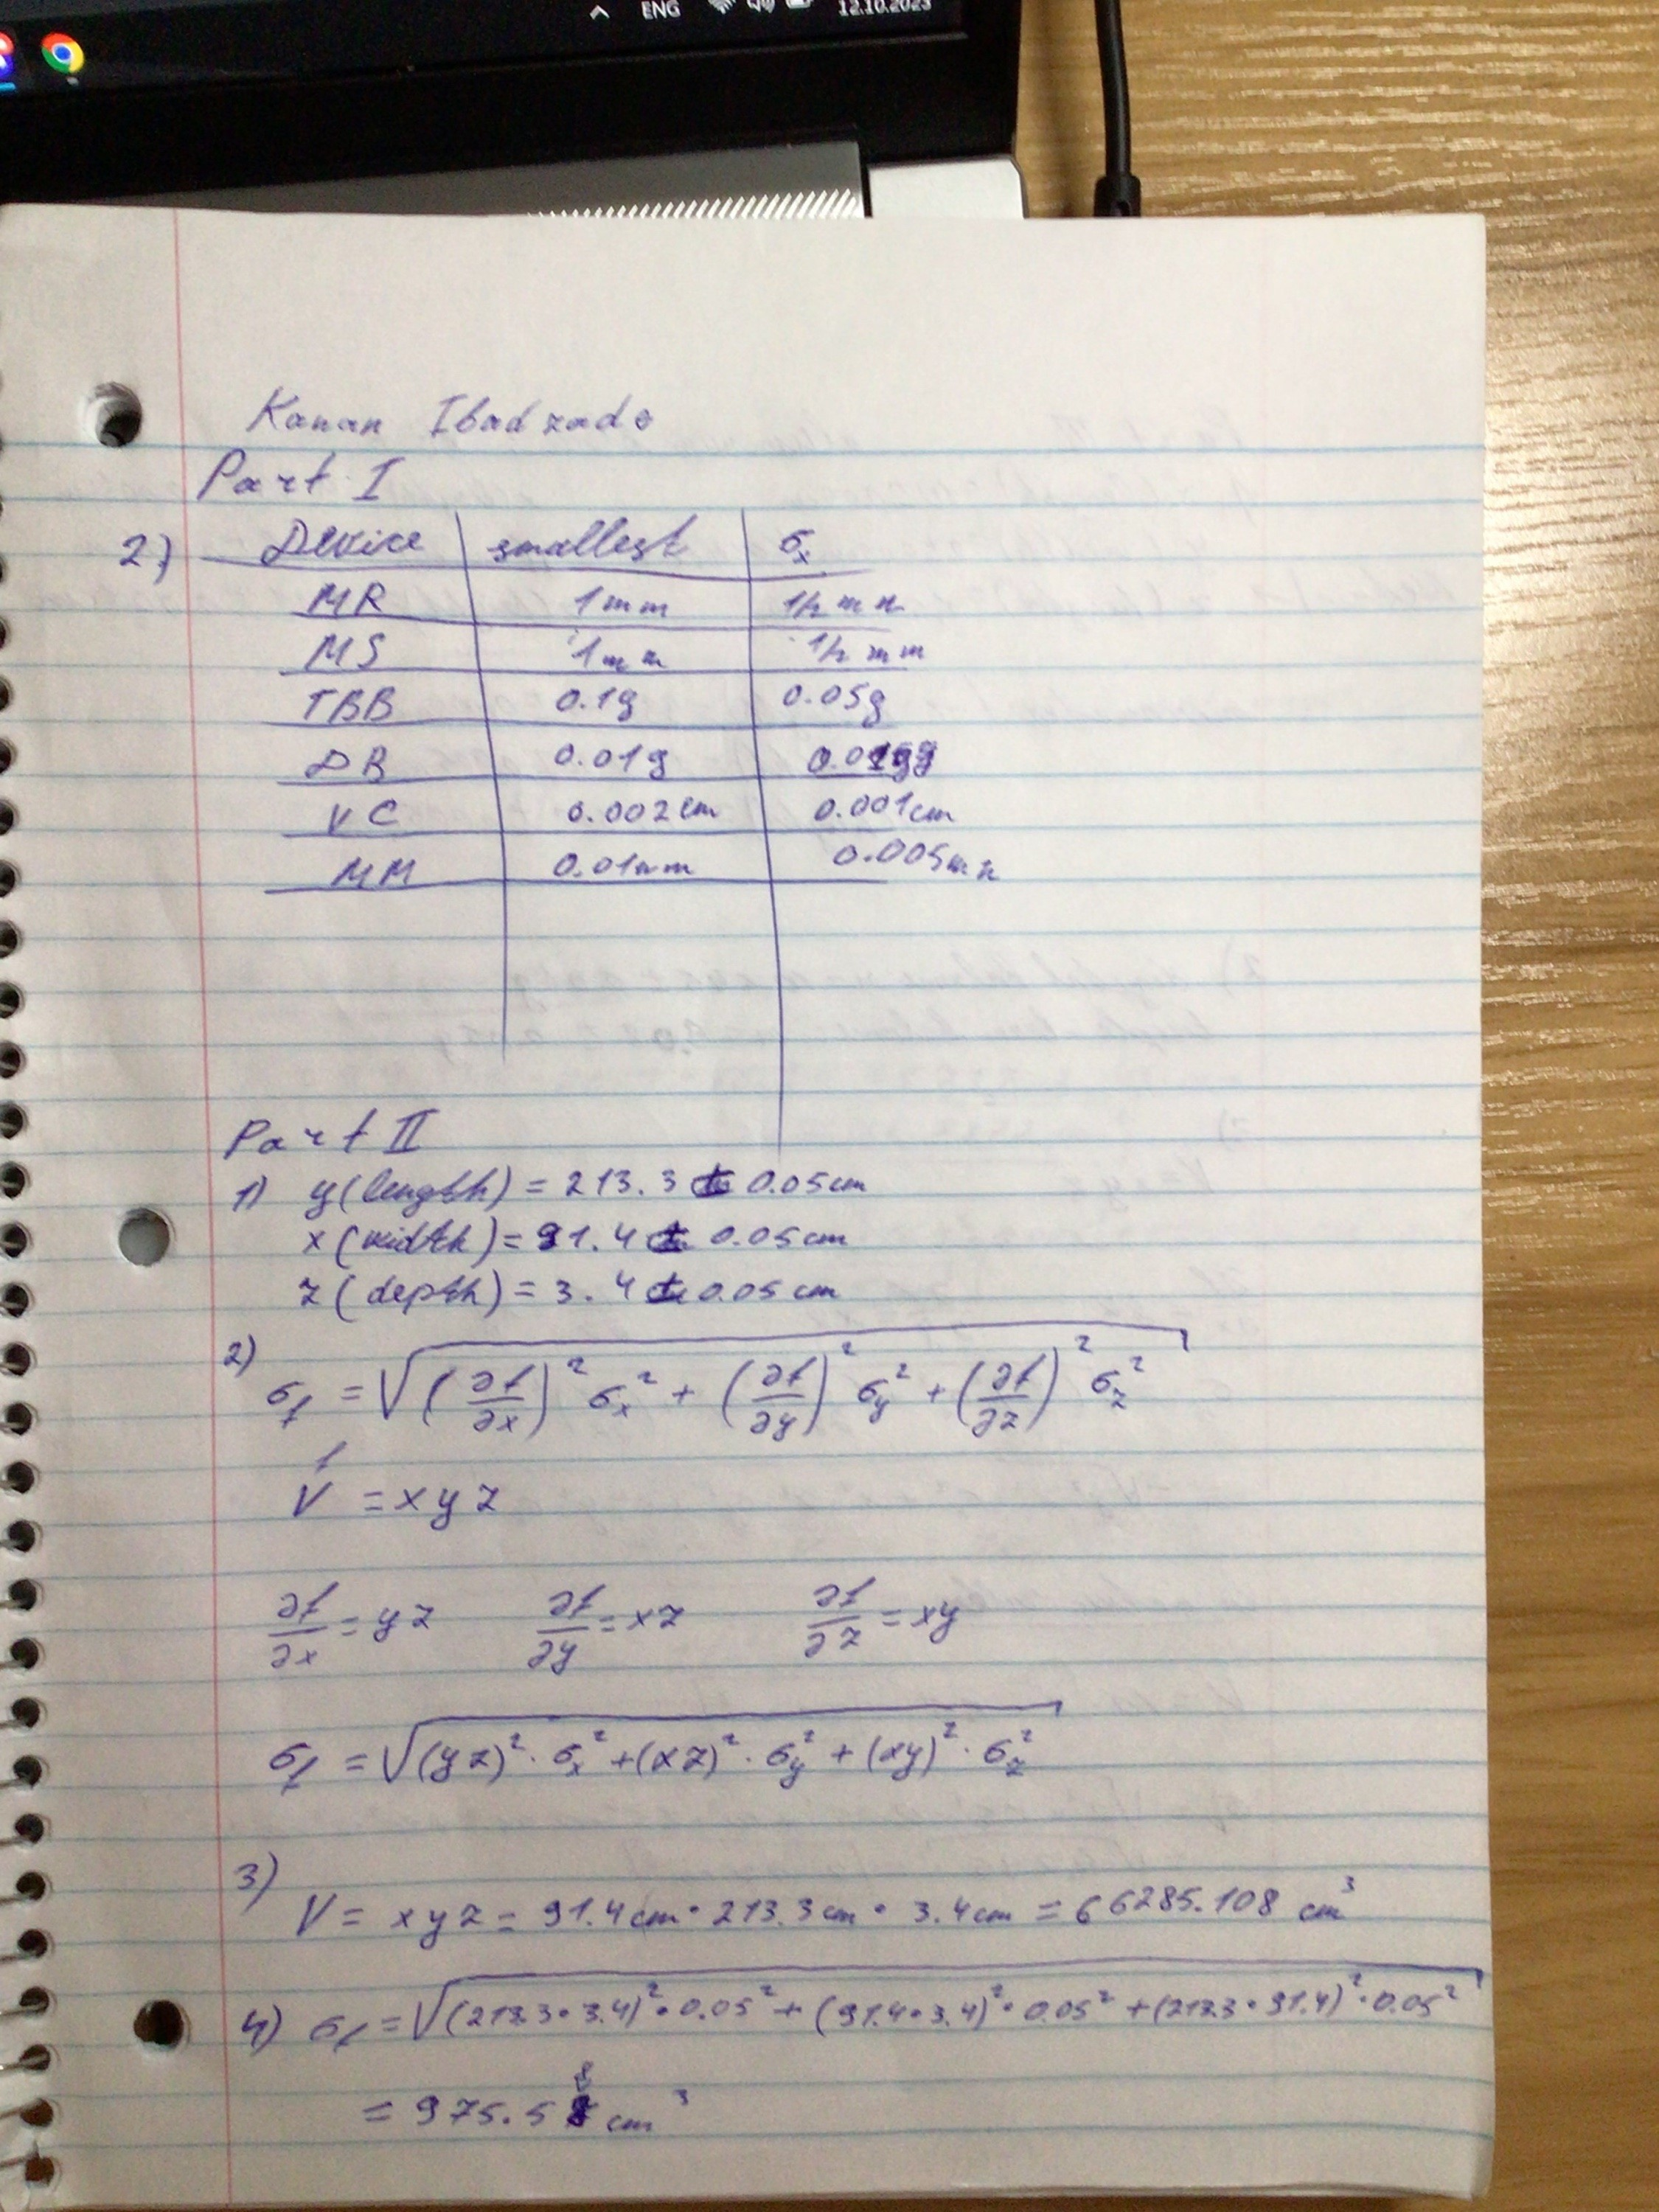

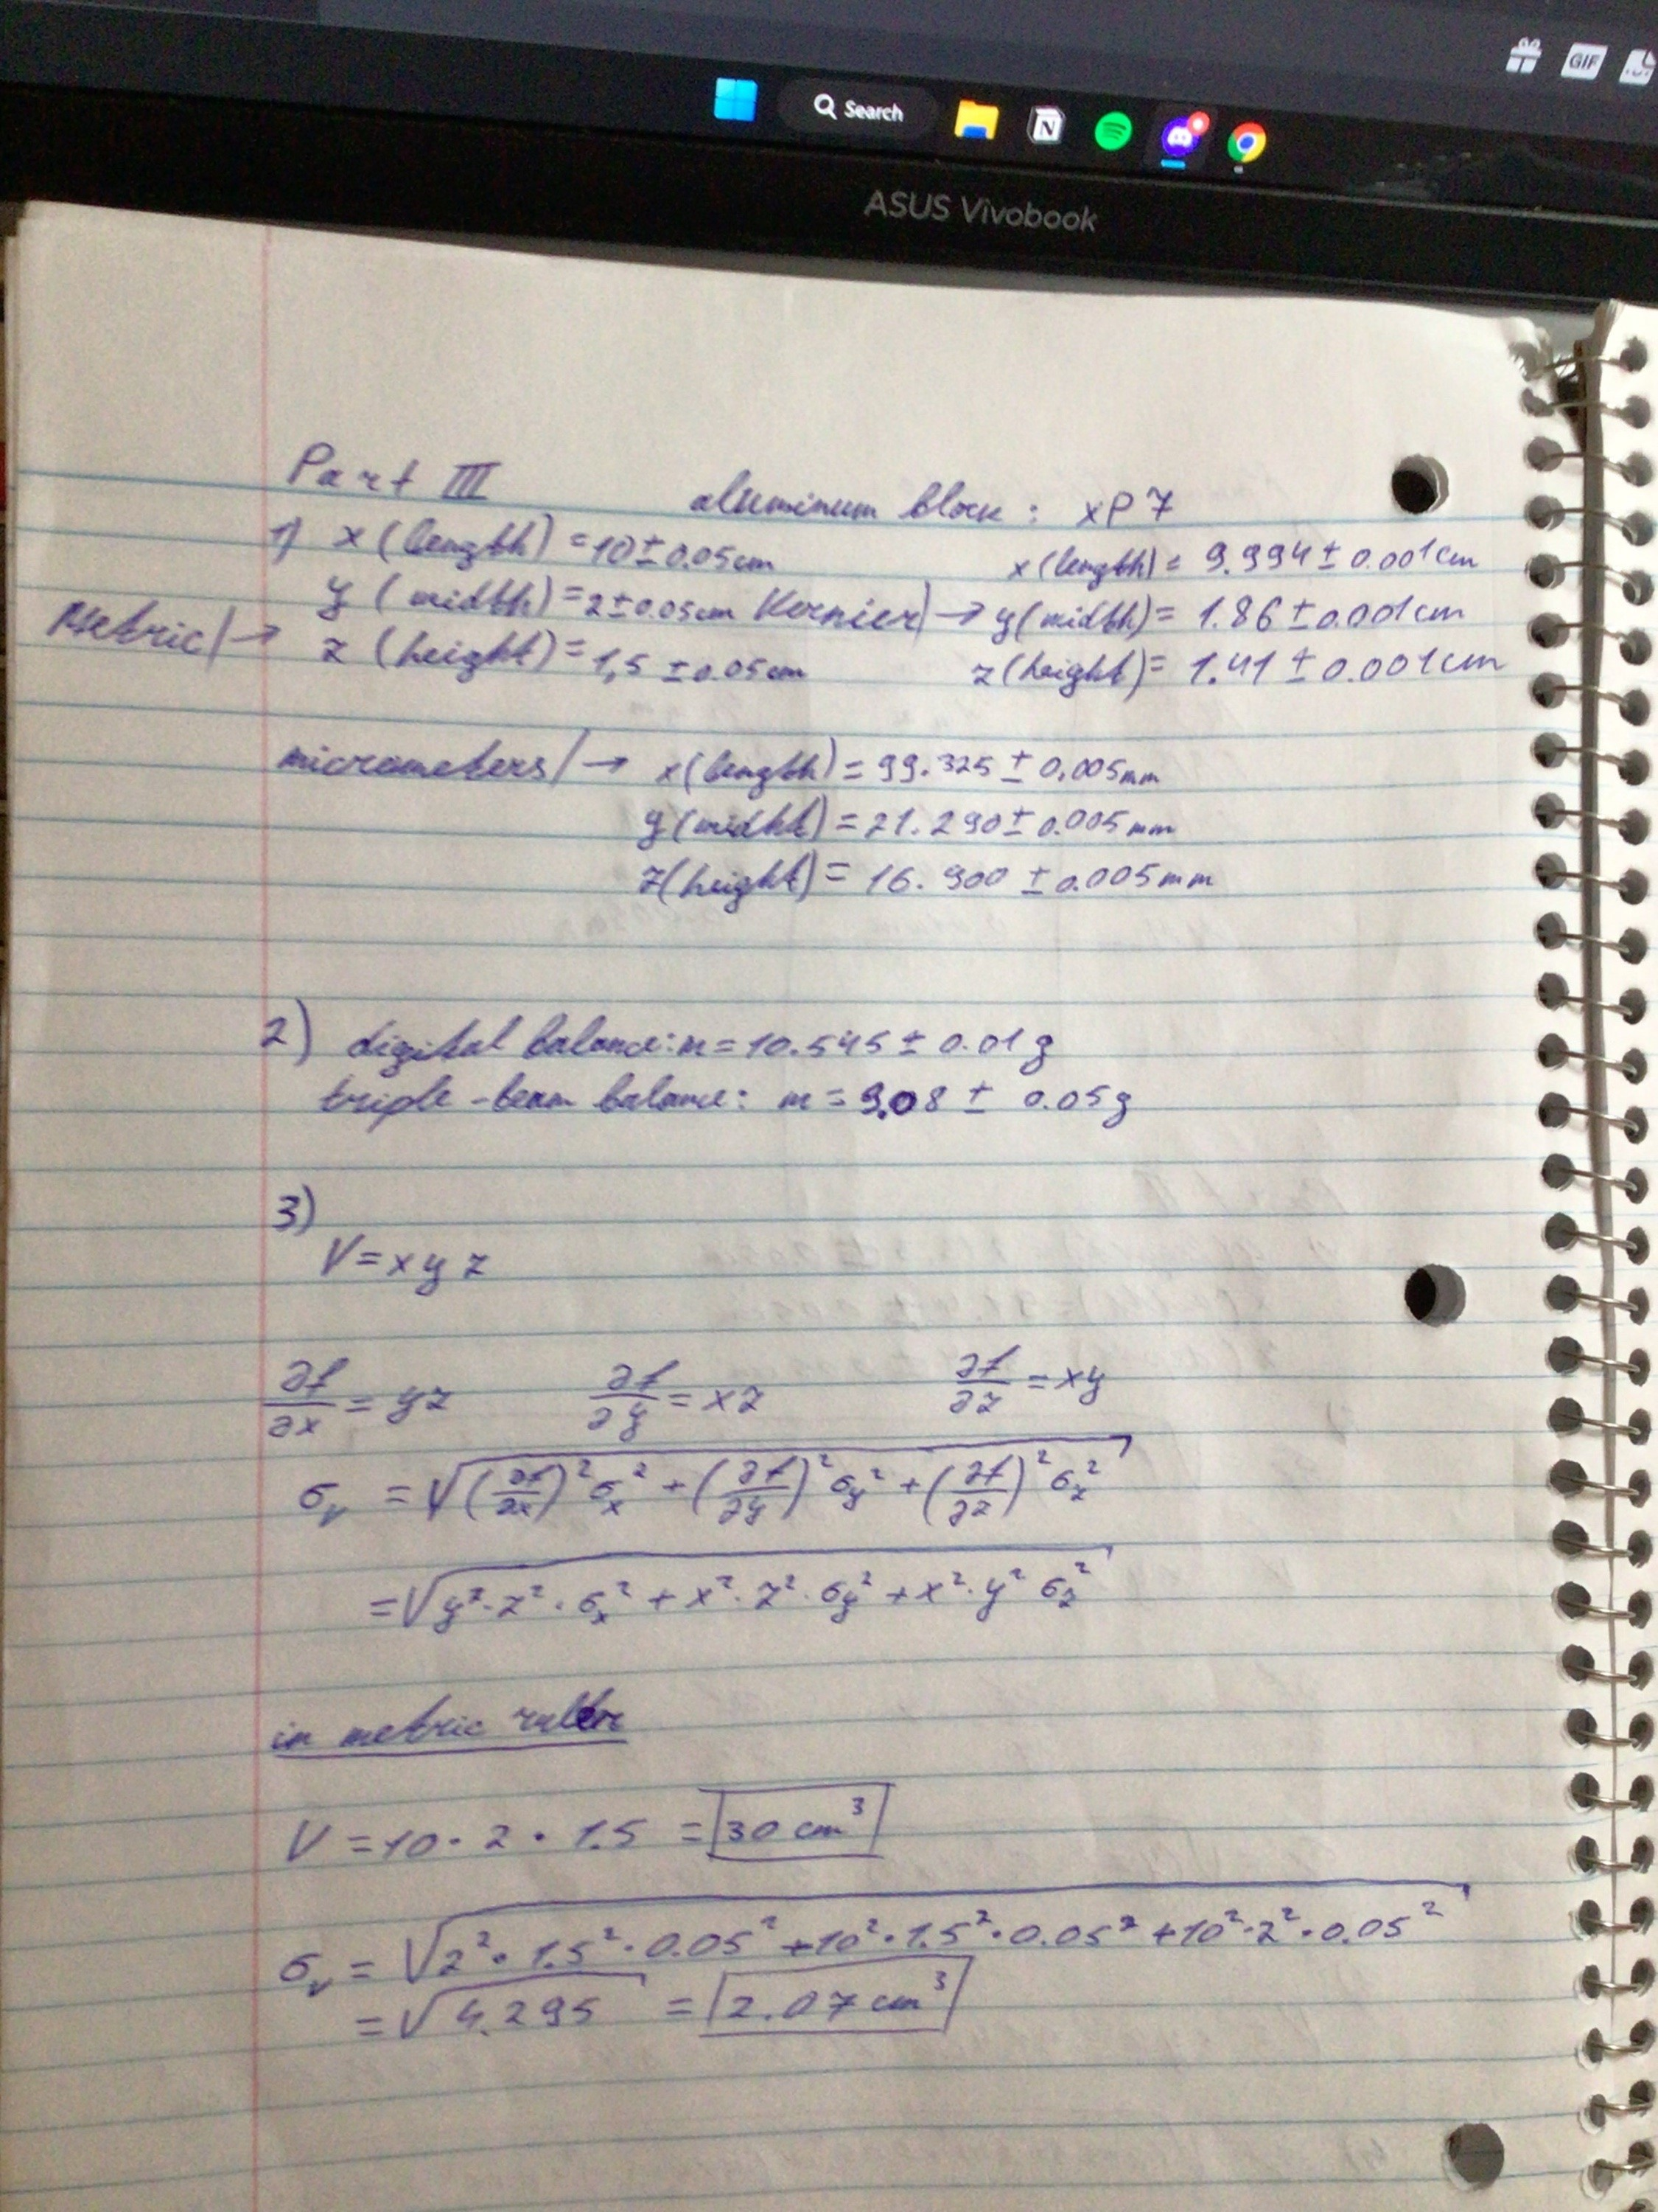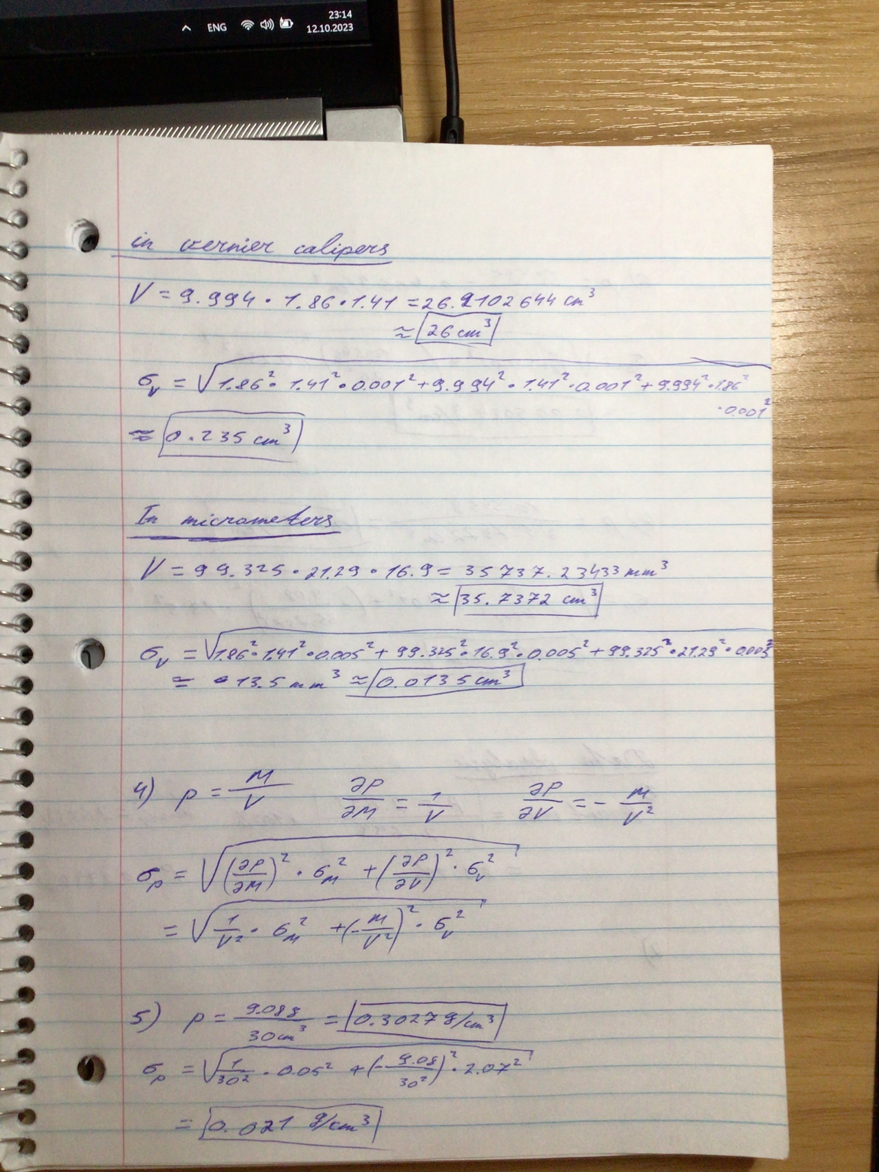

**8. CONCLUSION**

n

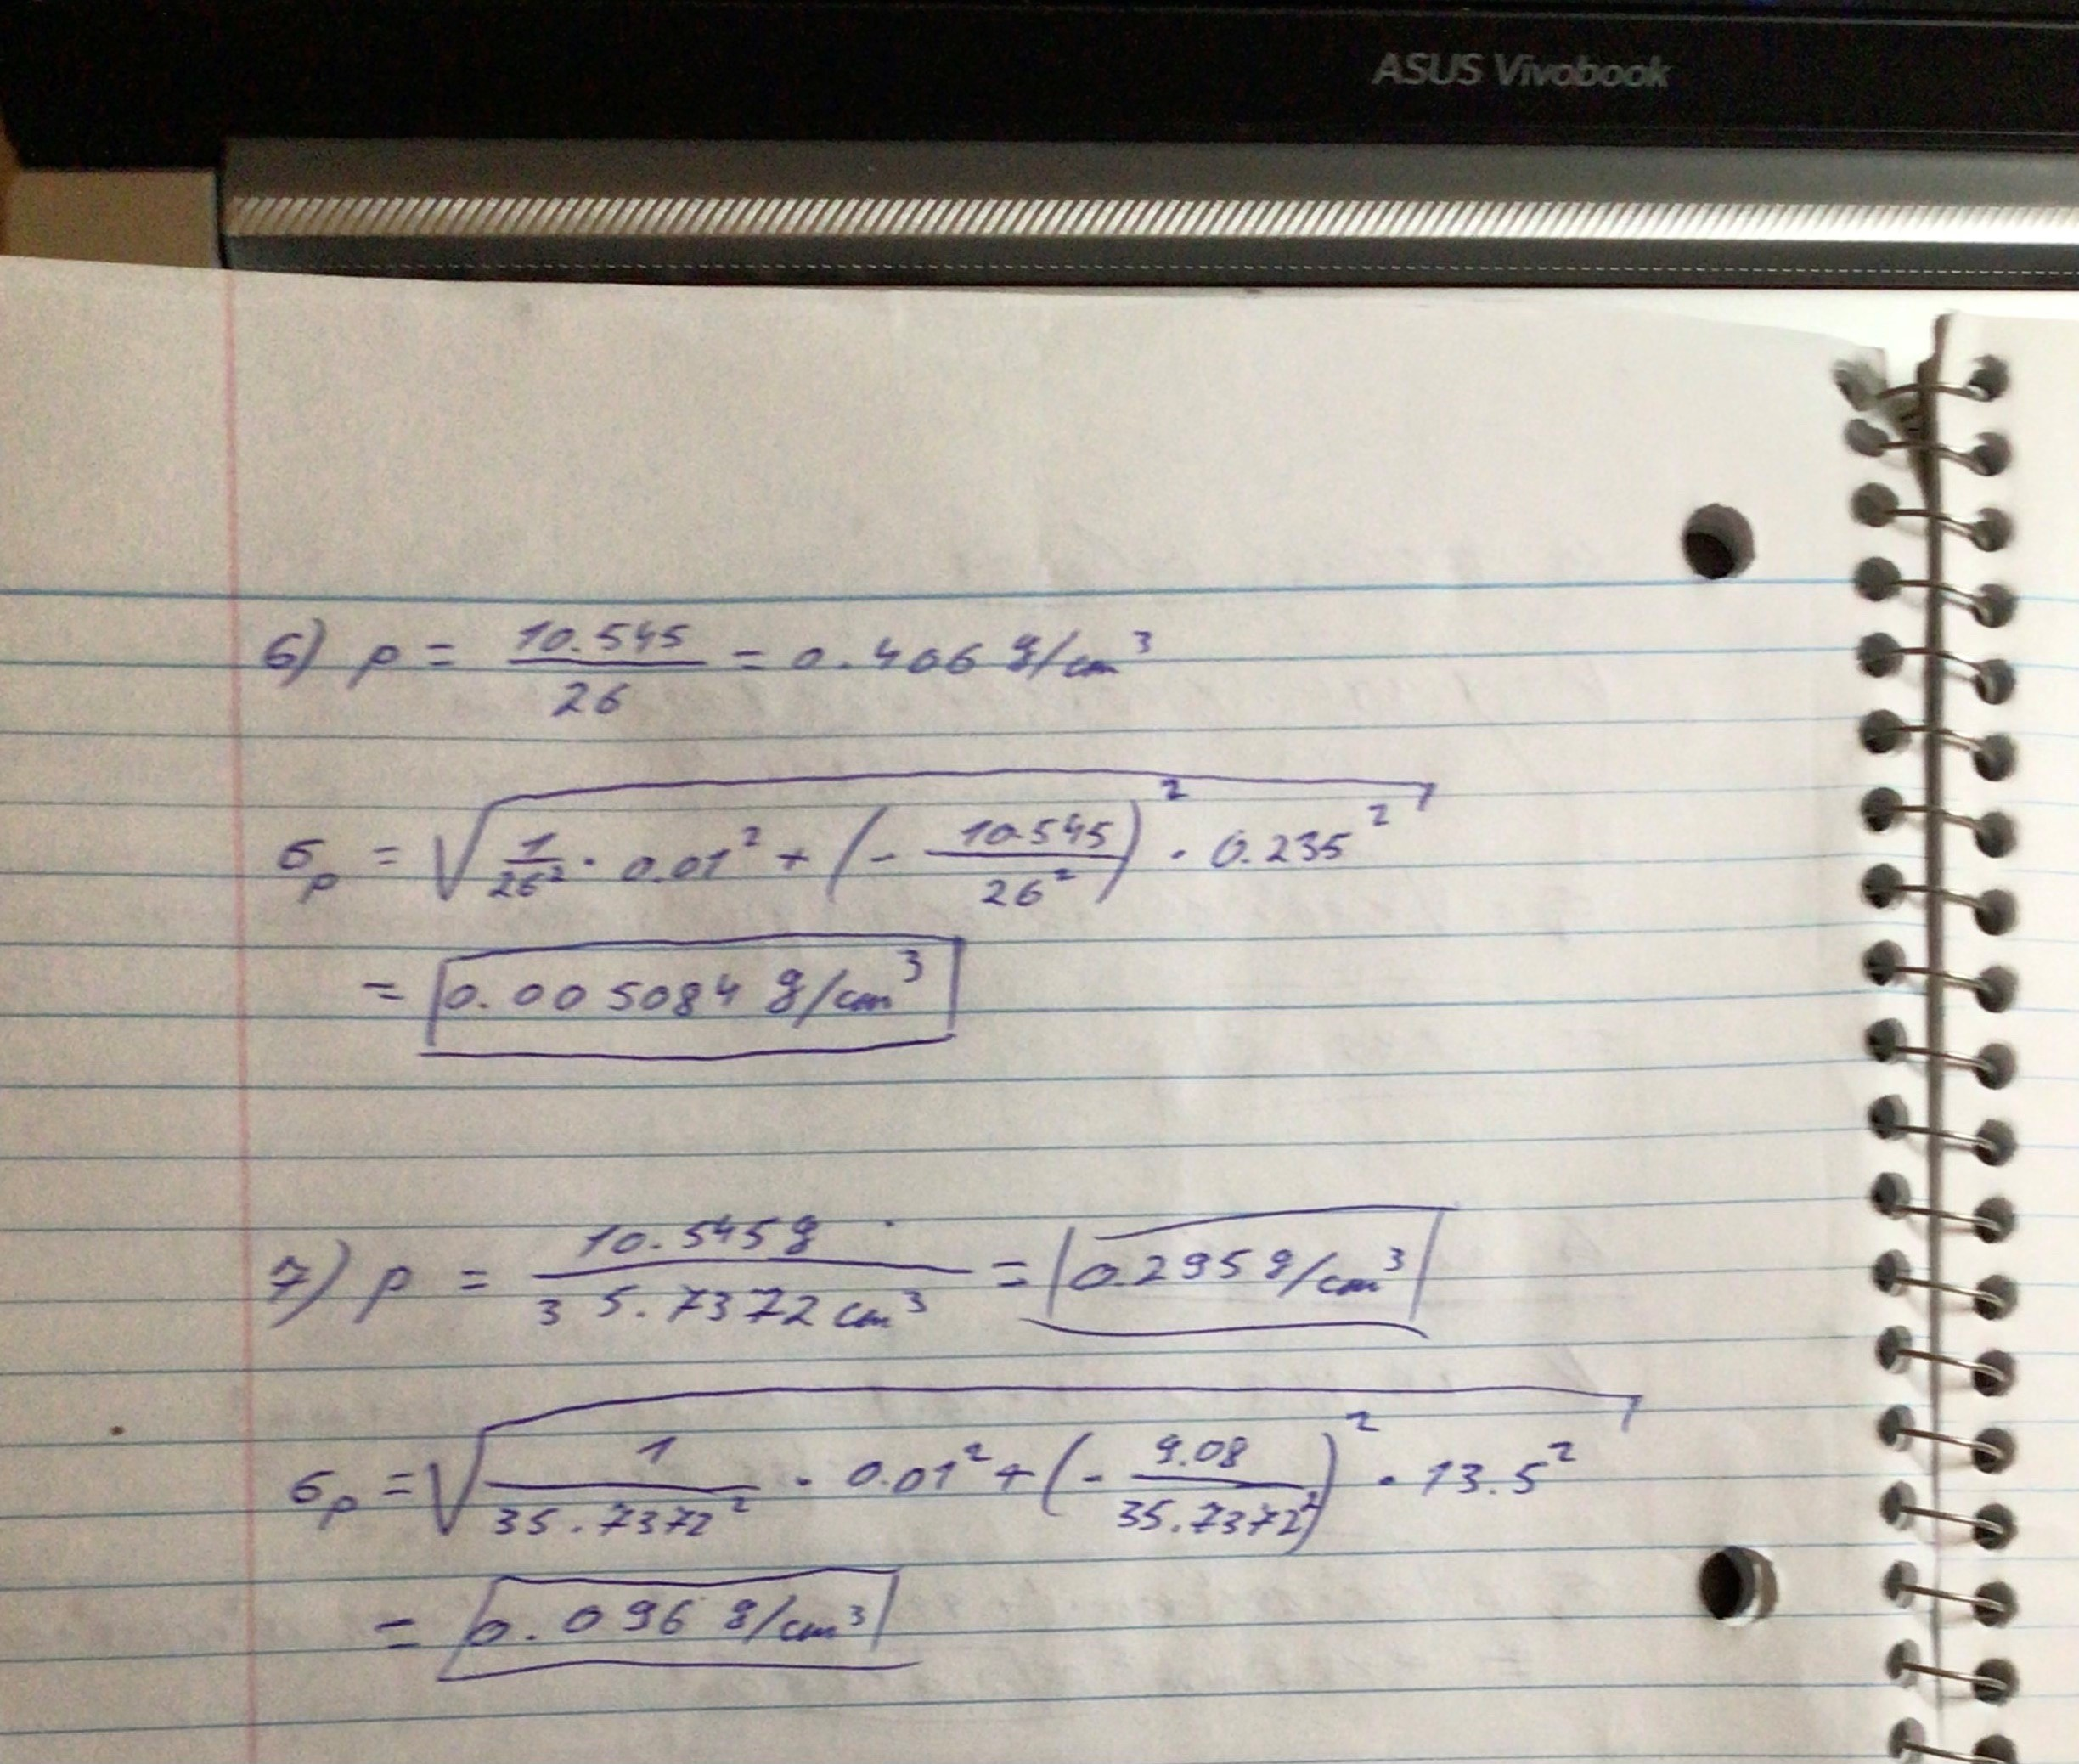

**Data Analysis:**

1)

2) To evaluate which one is most reliable and likely to be correct, we compare them against one another. When we compare those three figures, we can observe that the density determined by the vernier caliper and digital balance is somewhat different from the other two since they are so near to one another. Because of this, I believe that the density of 0.406 g/m3 is more correct.

3) The process of propagating error entails determining how the uncertainty in the final estimated quantity, such as density, is affected by the uncertainty in the measured numbers, such as length, breadth, height, and mass. The uncertainty in each measured quantity is taken into account when calculating volume and then density using the data that were supplied. We must transmit the mistakes from both the volume computation and the mass measurement when computing the density. We might consider how the computation of density is impacted by the uncertainty in mass as an example. Density will be more unpredictable as the mass uncertainty increases. The effect of propagating error from mass on the total uncertainty in density may be minimal if the uncertainty in mass is comparably modest to the errors in measurements of length, breadth, and height. On the other hand, if the measurement errors for length, breadth, and height are significant, they will predominate over the total density error.

4) The measured values of mass and dimensions (length, breadth, and height) may vary due to random mistakes. The computed density may be impacted by these factors. In addition, Observational errors, also known as measurement errors, arise from inaccuracies or uncertainties associated with the process of making measurements.

5) Measurement accuracy is impacted by systematic errors, which are frequent and predictable mistakes. Systematic mistakes consistently cause measurements to deviate from the correct value, in contrast to random errors, which are unexpected and have a tendency to balance out over repeated measurements. Because they consistently produce biases or changes in the observed values, they can have a major impact on how accurate density calculations are. These biases may affect the computed density as well as the predicted volume and mass.

6) The aluminum block's surface could not be completely level or smooth, especially near the edges. This may result in inaccurate length, width, and height measurements, which will influence the volume computation. Furthermore, the accuracy of measuring devices may fluctuate over time as a result of calibration drift. Errors may be introduced if the instruments were not recently calibrated or if they strayed while being measured.